Year One
Vehicle Text | Major Glad, Major  Dizzy   | Rapunzel  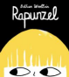 | Hermelin  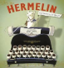 | Where the wild things are  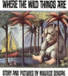 | The Secret of Black Rock  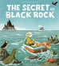 | The Last Wolf  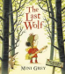
Narrative outcome | Discovery story  Purpose: To narrate | Instructions: How to catch a witch  Purpose: to instruct | Detective story | Portal story | Return story | Hunting story
Non-narrative  outcome | Recount: Messages Purpose: To recount | Recount: Messages  Purpose : to give  information | Recount: Letters  Purpose: to recount | Information: Wild things  Purpose: to  instruct | Recount: Postcards Purpose: to  recount | Instructions:  Recipes  Purpose: to inform

Year Two
Vehicle Text | A River  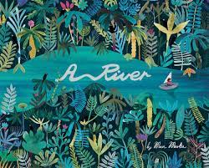 | The Night Gardener  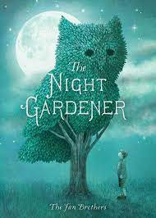 | Bog Baby  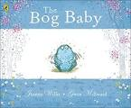 | Grandad’s Island  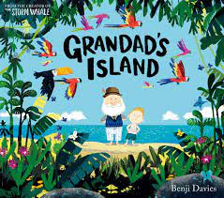 | The King Who Banned the Dark or Jack and the Beanstalk  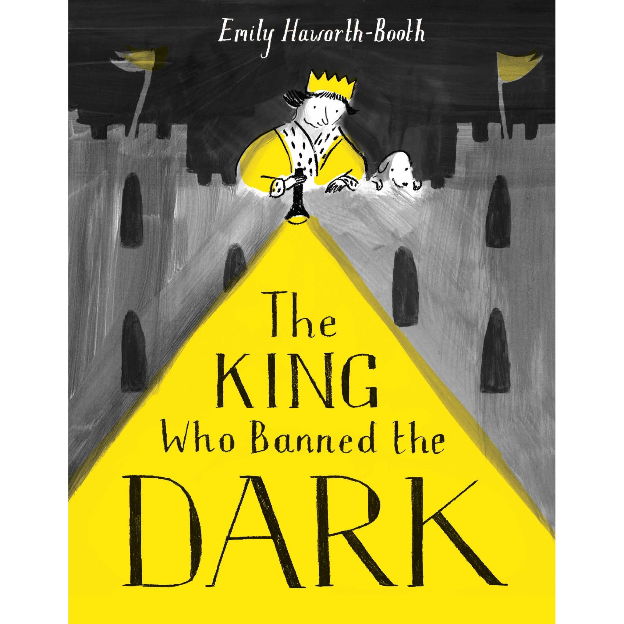  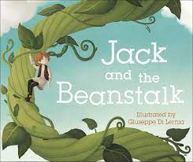 | Rosie Revere  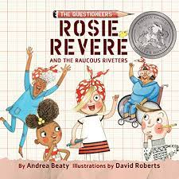
Narrative outcome | Narrative: Circular Narrative Purpose: To narrate | Narrative: Setting Narrative Purpose: To narrate | Narrative: Finding Narrative Purpose: To narrate | Narrative: Return Narrative Purpose: To narrate | Narrative: Mistake Narrative Purpose: To narrate | Narrative: Invention Narrative Purpose: To narrate
Non-narrative  outcome | Recount: Letter Purpose: To inform | Recount: Diary Purpose: To recount | Instructions: How to build a habitat Purpose: To instruct | Information: Jungle Animals Purpose: To inform | Information: How to be a Regal Leader Purpose: To inform | Explanation: How a machine works Purpose: To explain

Year Three
Vehicle Text | Fox  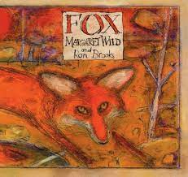 | Seen not heard  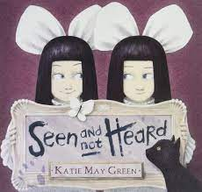 | The Iron Man  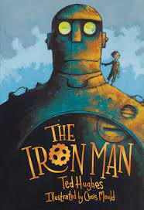 | Jemmy Button  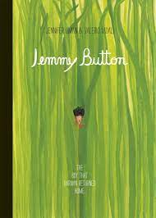 | Egyptology  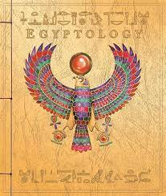 | Into the Forest  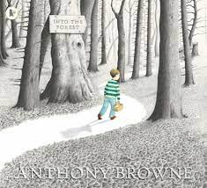
Narrative outcome | Narrative: Fable Narrative Purpose: To narrate | Narrative: Character Narrative Purpose: To narrate | Narrative: Approach Threat Narrative Purpose: To narrate | Narrative: Return Narrative Purpose: To narrate | Narrative: Egyptian Mystery Narrative Purpose: To narrate | Narrative: Lost Narrative Purpose: To narrate
Non-narrative  outcome | Information: Foxes Purpose: To inform | Instructions: How to be a mischievous child Purpose: To instruct | Explanation: How to capture the Iron Man Purpose: To explain | the Iron Man Purpose: To explain Information: Letters Purpose: To recount | Instructions: Secret Diary Purpose: To recount | Narrative: Lost Narrative Purpose: To narrate

Year Four
Vehicle Text | The Journey  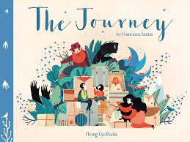 | Manfish  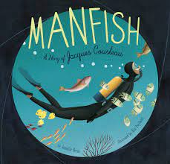 | Arthur and the Golden Rope  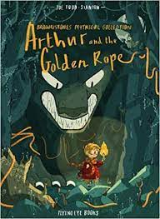 | The Lost Happy Endings  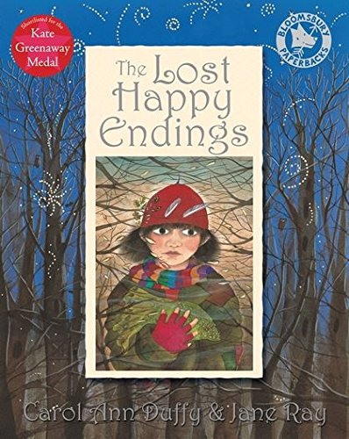 | The Whale  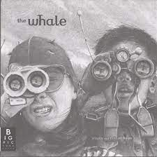 | Leaf  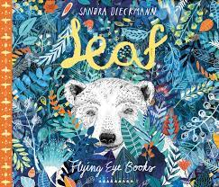
Narrative outcome | Narrative: Refugee Narrative Purpose: To narrate | Narrative: Invention Narrative Purpose: To narrate | Narrative: Myth Narrative Purpose: To narrate | Narrative: Twisted Narrative Purpose: To narrate | Narrative: Setting Narrative Purpose: To narrate | Narrative: Outsider Narrative Purpose: To narrate
Non-narrative  outcome | Recount: Diary Purpose: To recount | Recount: Jacques Cousteau Biography Purpose: To recount | Information: Defeating a Viking monster Purpose: To inform | Persuasion: Letter Purpose: To persuade | Recount: Newspaper Report Purpose: To recount | Information: Polar Bears Purpose: To inform

Year Five
Vehicle Text | Where Once We Stood  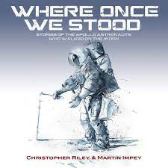 | The Hound of the Baskervilles  Thanks 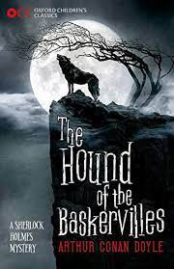 | Henry’s Freedom Box or The Promise  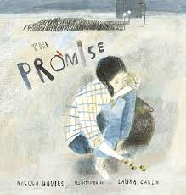  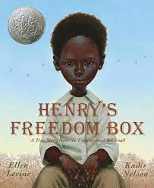 | FArTHER  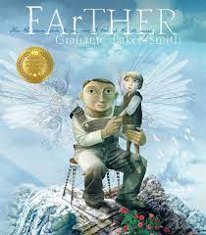 | The Lost Book of Adventure  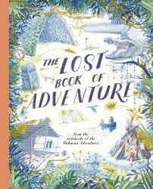 | King Kong  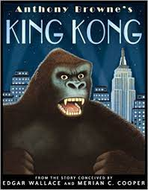
Narrative outcome | Narrative: Exploration Narrative Purpose: To narrate | Narrative: Cliffhanger Narrative Purpose: To narrate | Recount: Diary Purpose: To recount | Narrative: Setting Narrative Purpose: To narrate | Narrative: Survival Narrative Purpose: To narrate | Narrative: Dilemma Narrative Purpose: To narrate
Non-narrative  outcome | Recount: Formal Report Purpose: To recount | Recount: Formal Event Report Purpose: To inform | Recount: Henry Brown Biography Purpose: To recount | Recount: Letter Purpose: To recount | Explanation: Survival Guide Purpose: To explain | Discussion: Balanced Argument Purpose: To discuss

Year Six
Vehicle Text | Rose Blanche  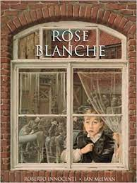 | A Story Like the Wind  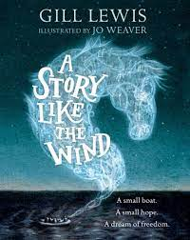 | The Origin of the Species  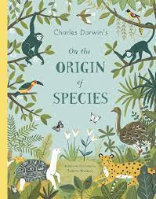 | Wolves  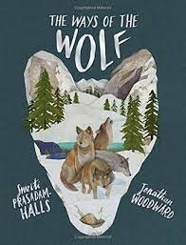 | Shackleton’s Journey  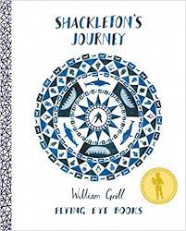 | Hansel and Gretel  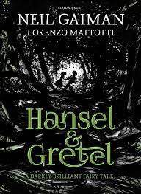
Narrative outcome | Recount: Diary Purpose: To recount | Narrative: Flashback Narrative Purpose: To narrate | Narrative: Discovery Narrative Purpose: To narrate | Recount: First Person Narrative Purpose: To narrate Discussion: Balanced Argument Purpose: To discuss | Narrative: Endurance Narrative Purpose: To narrate | Narrative: Dual Narrative Purpose: To narrate
Non-narrative  outcome | Recount: Bravery Speech Award Purpose: To recount & inform (hybrid) | Recount: Newspaper Report Purpose: To recount | Explanation: Adaptation Purpose: To explain | Information Text: Wolves Purpose: To inform Narrative: Suspense Narrative Purpose: To narrate | Recount: Magazine Article Purpose: To recount | Persuasion: Letter Purpose: To persuade

