Role play the story of Where the Wild Things Are

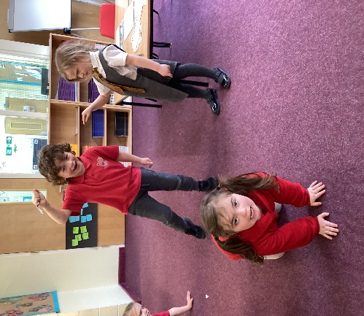 | Max caused  mischief of  one kind and  another. His mum called him ‘Wild Thing’ and he got sent to his room without any supper! | 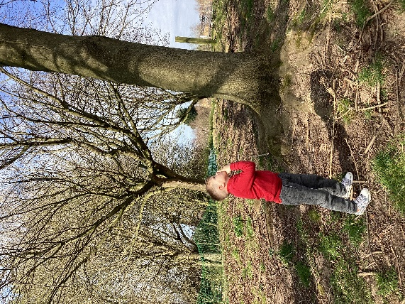 | That very night  in Max’s room, a  forest grew and  grew and grew  until the ceiling  hung with vines  and the walls  became the world  all around. | 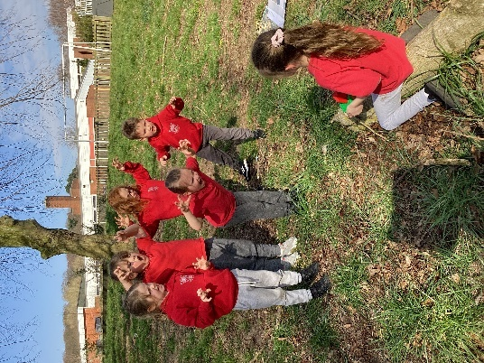 | He hopped in his boat and sailed to where the Wild Things were The Wild Things gnashed their terrible teeth, rolled their terrible eyes and roared their terrible roars.
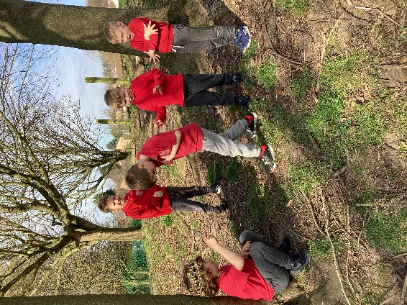 | Max said “be still!!” and tamed them with a magic trick. The Wild things were afraid of Max and called him the ‘Most Wild Thing of All’. They made Max King | 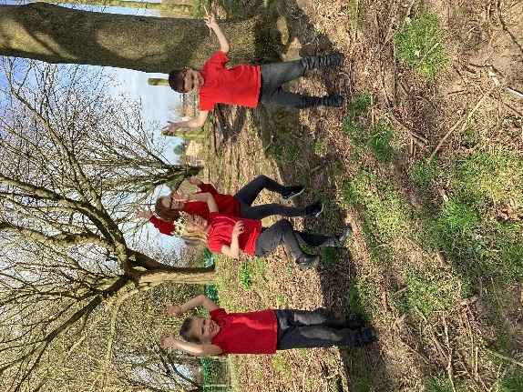 | Max and the Wild Things had a wild rumpus. They swung from tree to tree and danced all night until Max said “Now STOP!” and sent them to bed without their supper. | 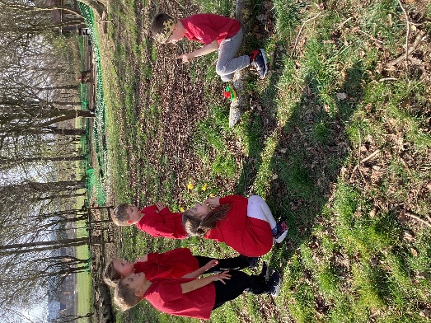 | Max enjoyed his time with the Wild Things but ne felt lonely and wanted to be where someone loved him the best. The Wild Things said “Please don’t go, we love you so” but Max said “NO!” and off he sailed.

