First, we children found out all about Andy Warhol and what he is famous for, we then explored and discussed the features of his work and recorded our newly found knowledge and understanding into a sketchbook.  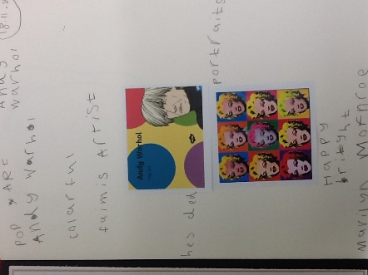 | We used Ipads to take some digital selfies (self portraits) and portrait style photographs of eachother.  Using our photographs and a mirror, we observed the features of our faces; noting the proportions and where each feature is positioned on the face. We looked at the shapes and colours of our features and sketched a self portrait using a charcoal pencil.  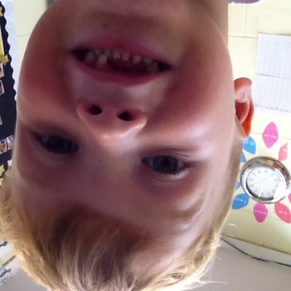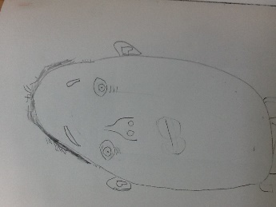
We then went on to explore hot and cold colours, contrasting and complimentaery colour using a variety of media. We looked at the clours that ‘POPPED’ (complimented eachother best) and chose our 4 favourite colours and our favourite media to creae a complimentary background.  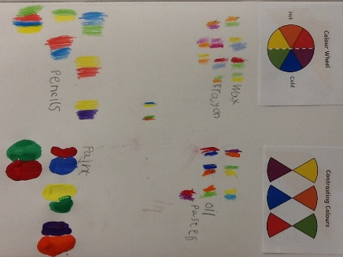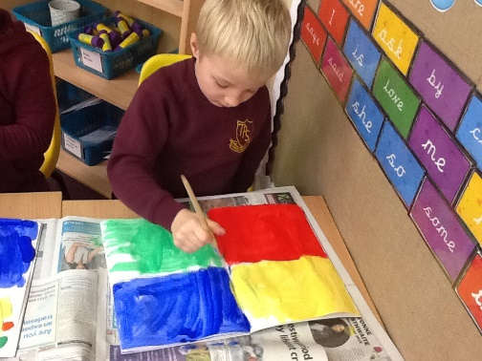 | After all of this exciting preperation, we carefully cut out four identical self portraits and glued them onto our vibrant backgrounds, just like Andy Warhol did. We then re-studied the features of Andy Warhol’s work and used the same media to add colour to our faces. Our finished pieces of art in the style of Andy Warhol are absolutely fantastic!!!  