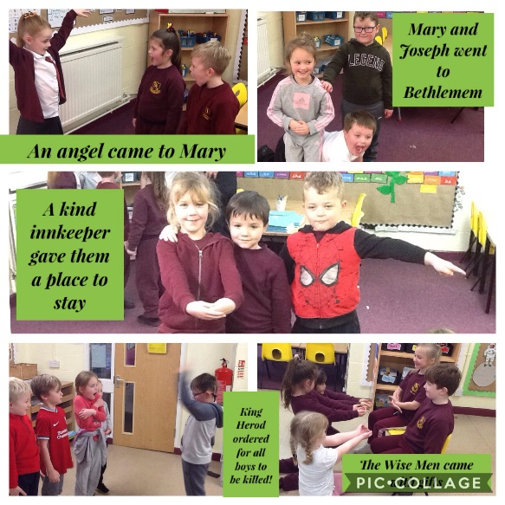
In RE this term we have been learning all about the story of Christmas.
We first explored the characters from the Nativity story; thinking about how each of the characters felt throughout the journey and how they behaved.
We then worked in our groups to role play the story, focusing on our body language, expression and the sequence of event.

We also learnt that the word CHRISTMAS means two things;
MASS is a church service of celebration so Christmas is a celebration of CHRIST. Christmas is celebrated by Christians.
In our next lesson, we revisited the story, sequenced the events through pictures and added captions to each of the scenes

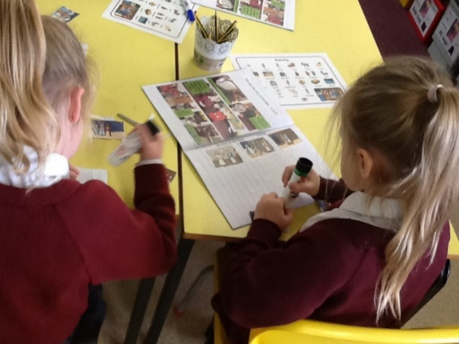
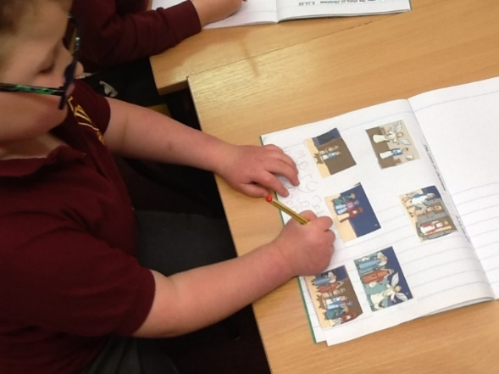
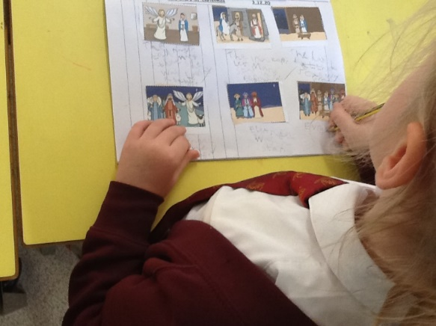

.
We then found out that Christians are part of communities ALL OVER THE WORLD and explored how Christmas is celebrated in lots of different countries.
From this we made comparisons on how Christmas is celebrated in the UK and Australia..
